PYTHON ASSIGNMENT 3 – PYTHON

WHILE LOOP, FOR LOOP, FUNCTIONS

TOOLS: Python / VS Code

PROJECT TITLE: Python Loops and Functions – While Loop, For Loop, Functions

PROJECT OBJECTIVE: Working with Loops (while, for), Control Statements (break, continue, else) and Functions – understanding iteration, repetition, flow control and reusable code in Python programs
DATE OF SUBMISSION: 12/10/2026 – 1:30 PM

1) NUMBER GUESSING GAME USING WHILE LOOP:
1.1) IMPORTING "RANDOM" MODULE IN THE NEW FILE "PYTHON WHILE LOOP.PY".
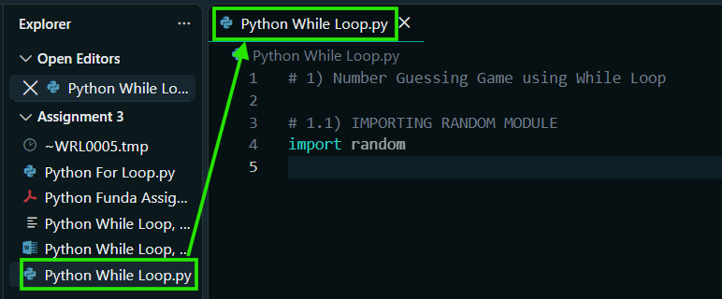
1.2) GENERATING A RANDOM SECRET NUMBER.
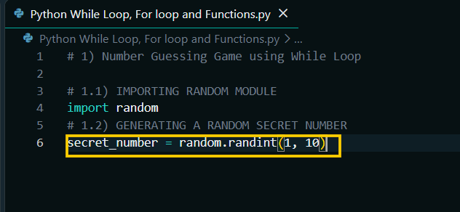
1.3) SETTING THE NUMBER OF ATTEMPTS.
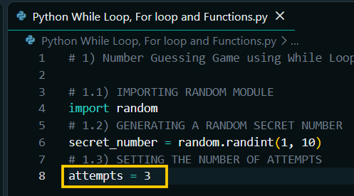
1.4) "WHILE" LOOP.
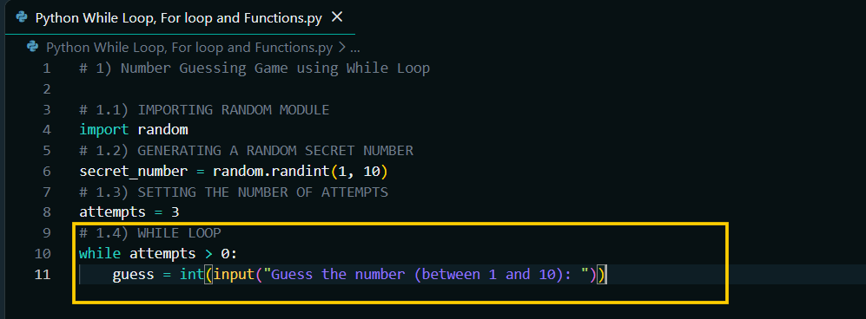
1.5) CHECKING IF THE GUESS IS OUT OF RANGE.
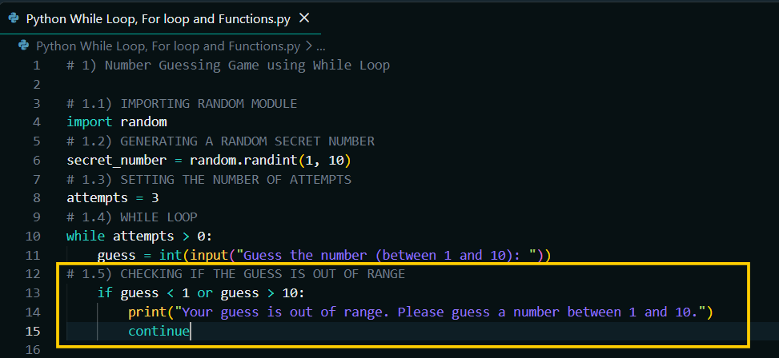
1.6) DECREASING THE NUMBER OF ATTEMPTS.
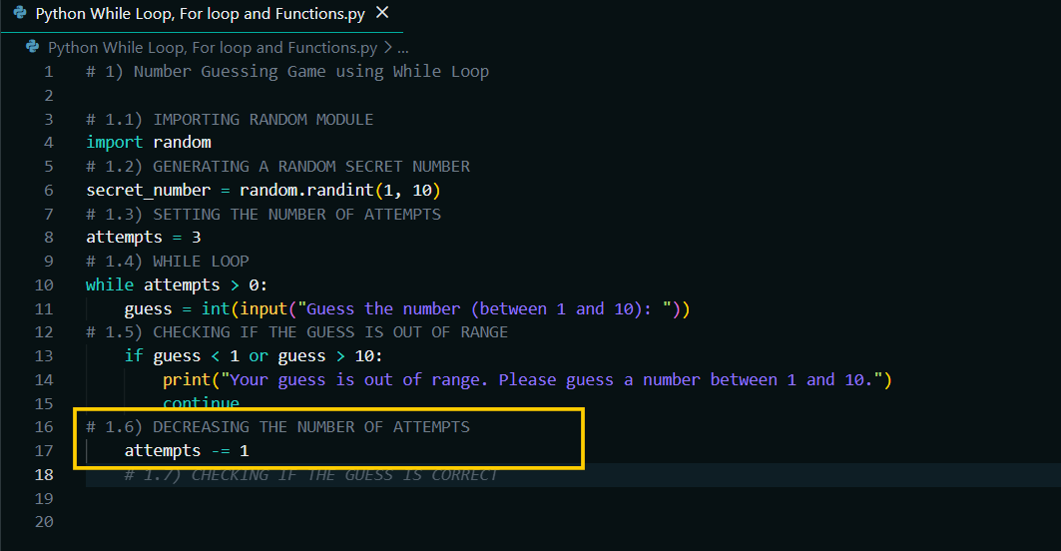
1.7) CHECKING IF THE GUESS IS CORRECT.
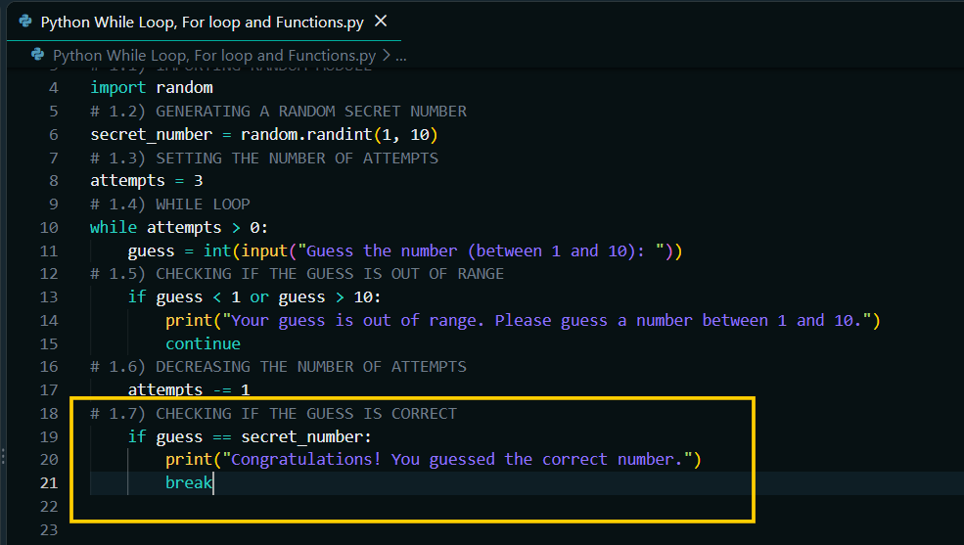
1.8) CHECKING IF THE GUESS IS TOO LOW.
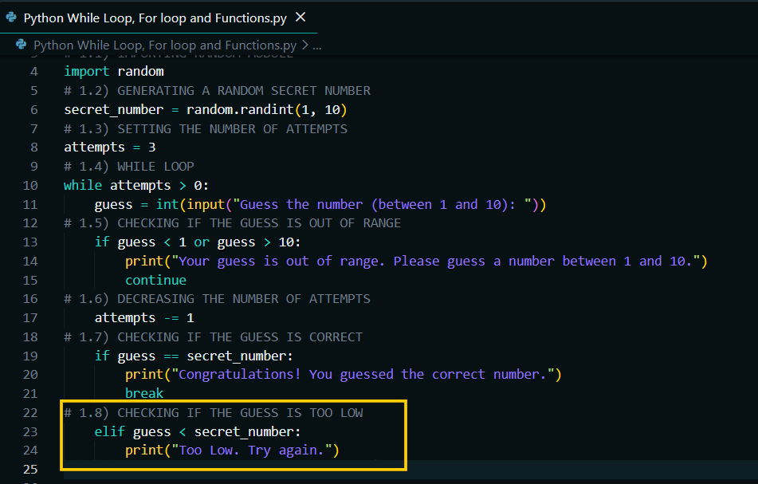

1.9) CHECKING IF THE GUESS IS TOO HIGH.
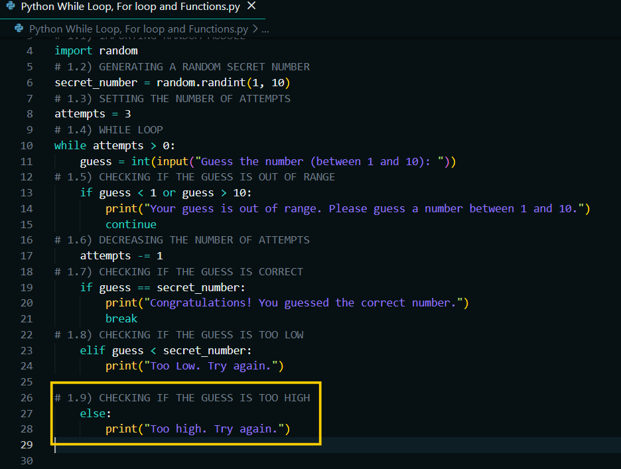
1.10) CHECKING IF THE USER HAS RUN OUT OF ATTEMPTS.
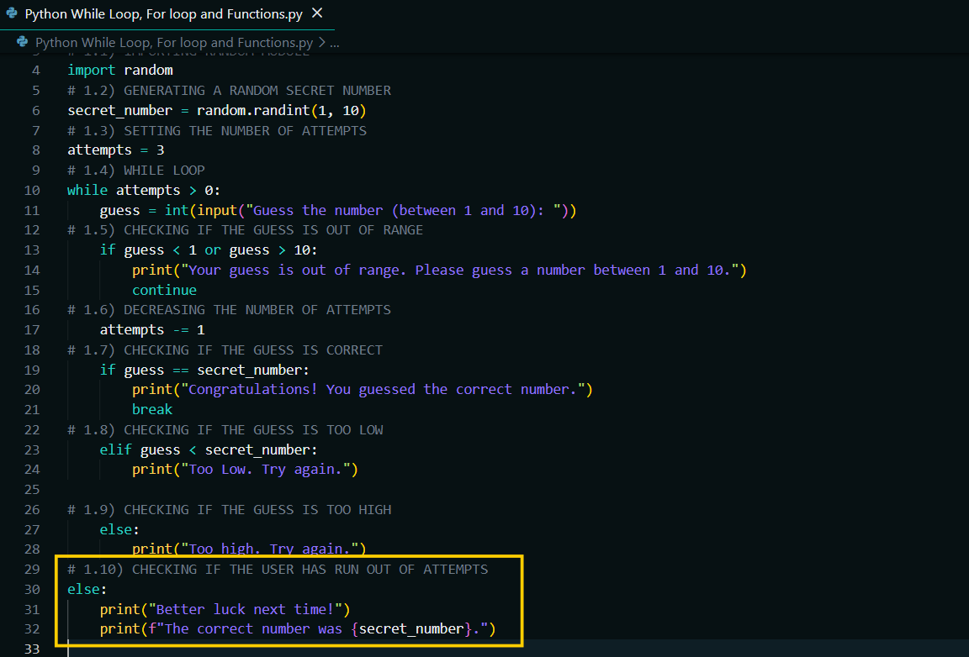
COMPLETE CODE OF THE NUMBER GUESSING GAME USING "WHILE" LOOP.
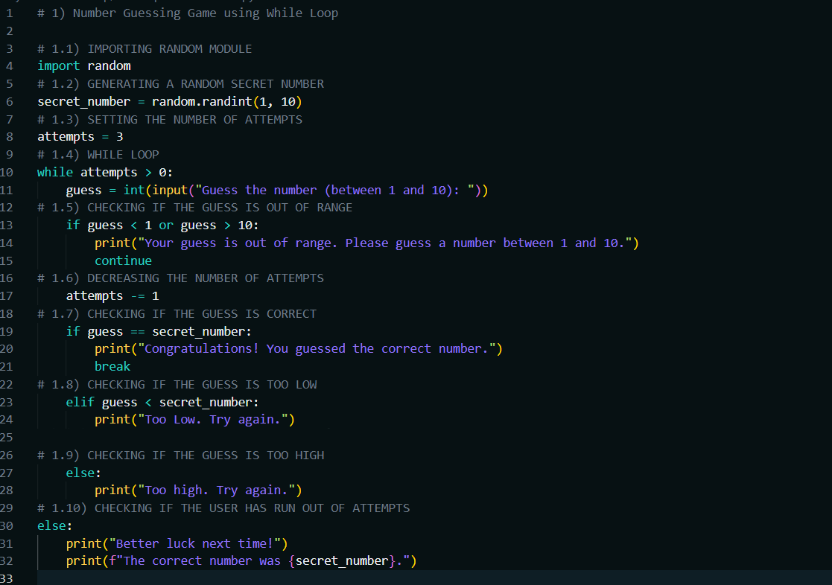

OUTPUT – NUMBER GUESSING GAME:
PS D:\ENTRI ELEVATE DOCUMENTS\PYTHON PROGRAM\Assignment\Assignment 3> & C:\Users\Venkadesh\AppData\Local\Programs\Python\Python314\python.exe "d:/ENTRI ELEVATE DOCUMENTS/PYTHON PROGRAM/Assignment/Assignment 3/Python While Loop.py"
Guess the number (between 1 and 10): 5
Too Low. Try again.
Guess the number (between 1 and 10): 7
Too Low. Try again.
Guess the number (between 1 and 10): 8
Congratulations! You guessed the correct number.
PS D:\ENTRI ELEVATE DOCUMENTS\PYTHON PROGRAM\Assignment\Assignment 3>

2) MULTIPLICATION TABLE GENERATOR USING FOR LOOP:
2.1) GETTING INPUT FROM THE USER IN THE NEW FILE "PYTHON FOR LOOP.PY".
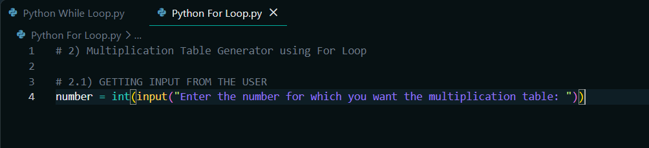
2.2) USING "FOR" LOOP.
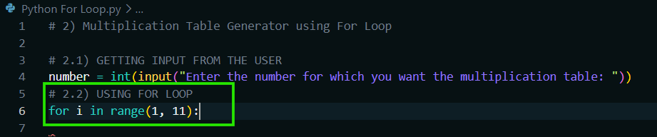
2.3) CALCULATING THE RESULT.
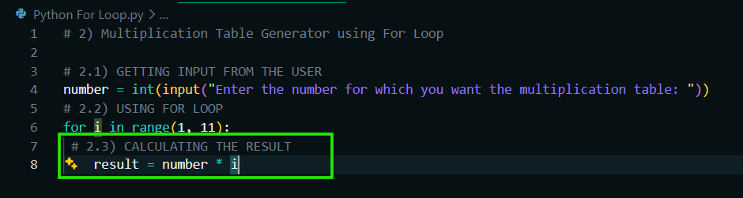
2.4) PRINTING THE MULTIPLICATION TABLE.
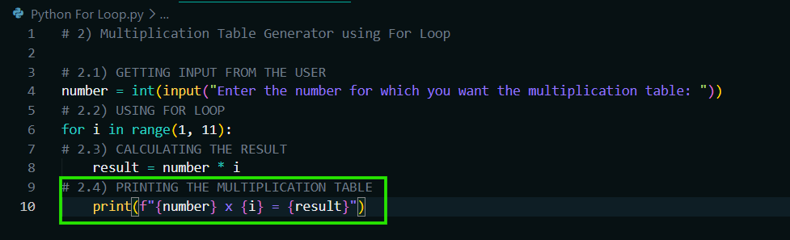
COMPLETE CODE OF THE MULTIPLICATION TABLE GENERATOR USING "FOR" LOOP.
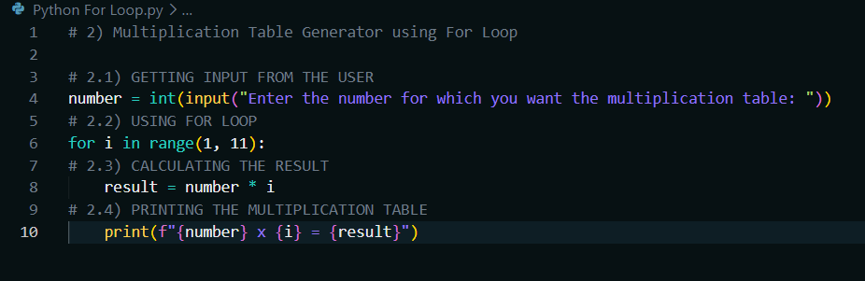
OUTPUT – MULTIPLICATION TABLE:

PS D:\ENTRI ELEVATE DOCUMENTS\PYTHON PROGRAM\Assignment\Assignment 3> & C:\Users\Venkadesh\AppData\Local\Programs\Python\Python314\python.exe "d:/ENTRI ELEVATE DOCUMENTS/PYTHON PROGRAM/Assignment/Assignment 3/Python For Loop.py"
Enter the number for which you want the multiplication table: 5
5 x 1 = 5
5 x 2 = 10
5 x 3 = 15
5 x 4 = 20
5 x 5 = 25
5 x 6 = 30
5 x 7 = 35
5 x 8 = 40
5 x 9 = 45
5 x 10 = 50

3) BMI CALCULATOR USING FUNCTION:
3.1) DEFINING THE FUNCTION IN THE NEW FILE "PYTHON FUNCTIONS.PY".
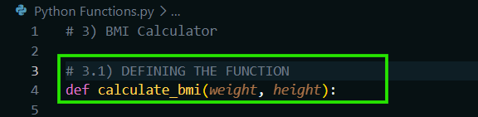
3.2) CALCULATING BMI.
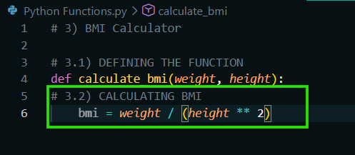
3.3) RETURNING THE RESULT.
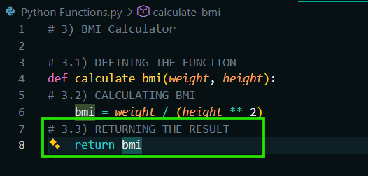
3.4) GETTING WEIGHT FROM THE USER.
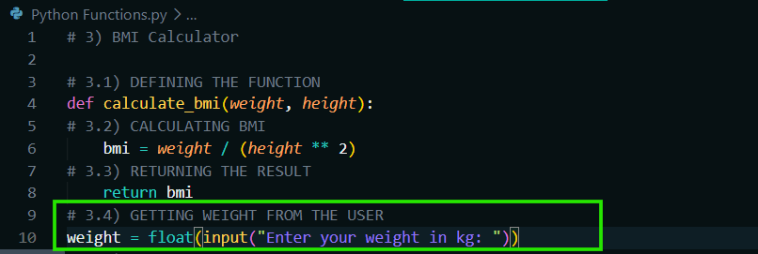
3.5) GETTING HEIGHT FROM THE USER.
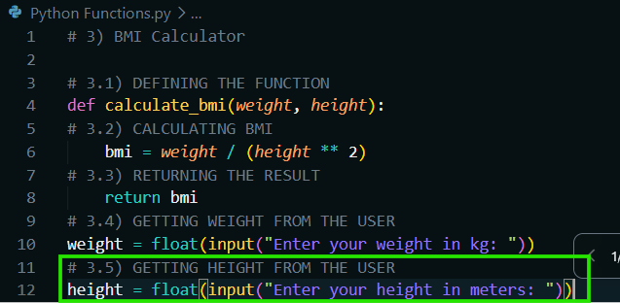
3.6) CALLING THE FUNCTION.
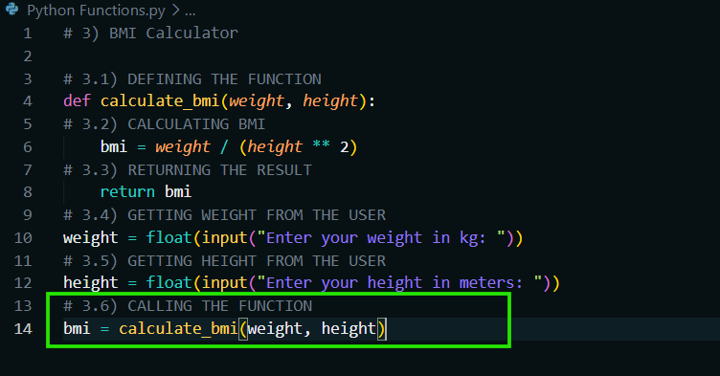
3.7) DISPLAYING THE BMI.
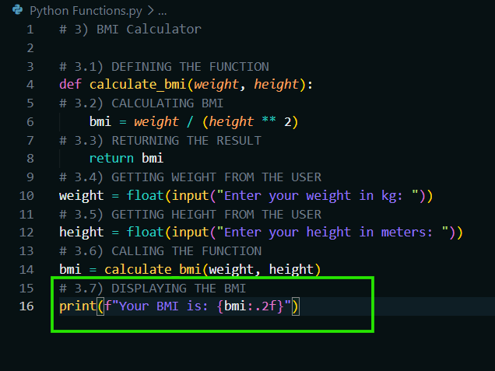

SOURCE CODE – BMI CALCULATOR:
# 3) BMI Calculator

# 3.1) DEFINING THE FUNCTION
def calculate_bmi(weight, height):
# 3.2) CALCULATING BMI
bmi = weight / (height ** 2)
# 3.3) RETURNING THE RESULT
return bmi
# 3.4) GETTING WEIGHT FROM THE USER
weight = float(input("Enter your weight in kg: "))
# 3.5) GETTING HEIGHT FROM THE USER
height = float(input("Enter your height in meters: "))
# 3.6) CALLING THE FUNCTION
bmi = calculate_bmi(weight, height)
# 3.7) DISPLAYING THE BMI
print(f"Your BMI is: {bmi:.2f}")

OUTPUT – BMI CALCULATOR:
PS D:\ENTRI ELEVATE DOCUMENTS\PYTHON PROGRAM\Assignment\Assignment 3> & C:\Users\Venkadesh\AppData\Local\Programs\Python\Python314\python.exe "d:/ENTRI ELEVATE DOCUMENTS/PYTHON PROGRAM/Assignment/Assignment 3/Python Functions.py"
Enter your weight in kg: 88
Enter your height in meters: 1.78
Your BMI is: 27.77
PS D:\ENTRI ELEVATE DOCUMENTS\PYTHON PROGRAM\Assignment\Assignment 3>

